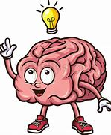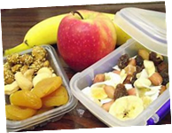

**Snack & Study: Fuel Your Body - Fuel Your Brain**

Join us in the library to get ready for finals week!

Monday, December 4th through Thursday, December 8th: 9:00 a.m. – 5:00 p.m.

Friday, December 9th: 9:00 a.m. – 2:00 p.m.

Snacks provided by ASCC, tutors, workshops & more to help YOU prepare for final exams!

Come to the library the week of December 4th during the hours above for free snacks, tutoring support, reference and instruction librarians, counseling & health workshops, and student success coaches!

**Schedule of Events/Tutoring Support**

**Tutoring Support:** All tutoring will take place in the library. Tutors normally scheduled in the Language & Writing Center, STEM Center, and Accounting & Business Center can be found in the library during this week. View Schedules online: [www.clark.edu/cc/tutoring](http://www.clark.edu/cc/tutoring)

**Counseling & Health Center Micro-Workshops:** Micro workshops shrunk to 30 minutes to give you the best support in the shortest amount of time!  Be sure to visit these during the week!

**Overcoming Test Anxiety:** Learn some effective strategies for overcoming test anxiety and feeling prepared before finals!

**Tuesday, December 5th from 12:20pm to 12:50pm & Wednesday, December 6thfrom 1:00pm to 1:30pm**

**Creative Stress Management:** Learn and practice tips for stress management in fun and creative ways!

**Tuesday, December 6th from 1:00pm to 1:30pm & Wednesday, December 7th from 12:20 pm to 12:50pm**

**There will be Student Success Coaches and Reference and Instruction Librarians on hand throughout the days to provide support and information as well!**

**ASCC will be providing snacks throughout the day to keep you fueled!**